1. VARIANTA : Fraction 🡨 FracionArray.

package com.company;  
  
class Fraction {  
 int num,denum;  
 Fraction(){  
 num=0;  
 denum=0;  
 }  
 Fraction(int num, int denum){  
 this.num=num;  
 this.denum=denum;  
 if(denum == 0) {  
 throw new IllegalArgumentException("Numitorul este 0");  
 }  
 reduce();  
 }  
  
 public void setNum(int num){  
 this.num=num;  
 }  
 public int getDenum(){  
 return denum;  
 }  
 public void setDenum(int denum){  
 this.denum=denum;  
 }  
 public int CalcGcd(int num,int denum){  
 if(num % denum==0){  
 return denum;  
 }  
 return CalcGcd (denum,num%denum);  
 }  
 void reduce(){  
 int gcd=CalcGcd (num,denum);  
 num/=gcd;  
 denum/=gcd;  
 }  
 public Fraction mult(Fraction two){  
 int newNumerator=num\*two.num;  
 int newDenumerator=denum\*two.denum;  
 return new Fraction (newNumerator,newDenumerator);  
 }  
 public String toString(){  
 return this.num+"/"+denum;  
 }  
}

package com.company;  
  
public class FractionArray extends Fraction{  
 private FractionArray[] f4=new FractionArray[10];  
 private FractionArray[] f5 = new FractionArray[100];  
  
  
 FractionArray(int num, int denum) {  
 super.num=num;  
 super.denum=denum;  
 }  
  
  
 public FractionArray mult(Fraction two){  
 int newNumerator=num\*two.num;  
 int newDenumerator=denum\*two.denum;  
 return new FractionArray (newNumerator, newDenumerator);  
 }  
 void adaugare11(){  
 for(int i=0;i<f4.length;i++){  
 f4[i]=new FractionArray (num+i,denum\*(i+1));  
 }  
 }  
 void afisare11(){  
 for(int i=0;i<f4.length-1;i++){  
 f5[i]=f4[i].mult (f4[i+1]);  
 System.*out*.println("Fractia "+f4[i]+" inmultita cu vractia "+f4[i+1]+" va fi : "+f5[i]);  
 }  
 }  
  
}

package com.company;  
  
import java.util.Scanner;  
  
public class Main {  
  
 public static void main(String[] args) {  
  
 Fraction f1=new Fraction(25,35);  
 Fraction f2=new Fraction(2,7);  
 Fraction f3=f1.mult (f2);  
 System.*out*.println(f3);  
 FractionArray ff=new FractionArray (2,7);  
 ff.adaugare11 ();  
 ff.afisare11 ();  
  
  
  
 }  
}

Rezultat:

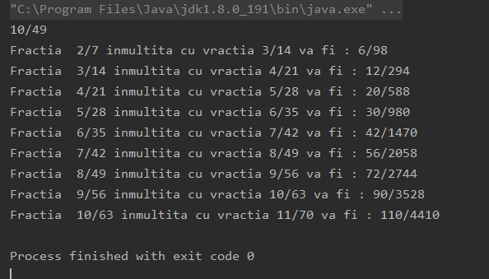

Concluzii:

Pentru elaborarea laboratorului nr.4,am studiat Polimorfismul și am lucrat cu ierarhiea claselor și am aplicat cunoștințele obținute.